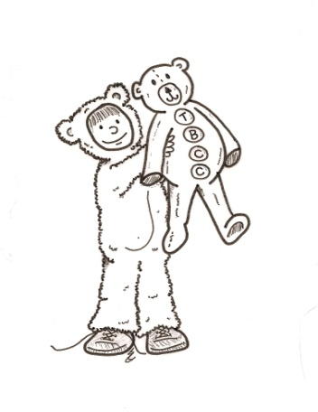 Preschool Class Schedule
*Please note the schedule does change dependent on the children’s needs

Name of Activity:
7-8:30 Arrival: AM snack,Free Play ***

Transition (Clean-up/ Restroom)

9:00 Breakfast

Transition (Clean-up/ Restroom)

8:45 classes separate into 2 groups

9:30 morning activity/creative art

10 Outside Play/Gross Motor Play/free play

10:30 Science/social studies

11:00 Circle Time

Transition (Clean-up/Restroom)

11:30 Lunch Time

11:30 Math/or free play

12 Free play

Transition (Clean-up/Restroom)

12:15 quiet activity/ story time-

12:30-2:30 Rest Time

1:00 quiet activities for non-sleeping children/individual learning after 30 minutes

2:30 Restroom/Brush Teeth/break time and Quiet Activities

3:00 Snack Time

3:30 Music and movement/or free play

4:00 Afternoon activity/small group

Transition (Clean-up/Restroom)

4:15 centers /small group/or free play

4-6 Outside Play/ Gross Motor/Free play

- While children are arriving in the morning, work with individual children on letters and numbers of the week
- Circle time: calendar, weather, letters. & numbers end with a story
- Meals and snacks: Teacher put on apron, hair net and gloves- check special diets- halal, vegetarian, lactose free, gluten free
- Morning project, math science, music and movement from curriculum package
- Science project from pack
- Additional free play between scheduled times

